MOVIE SEARCH APP

API INTEGRATION PROJECT

DOCUMENTATION

Internship: Frontend Developer Intern at ALFIDO TECH
Task: API Integration Project – Movie Search App
Developed By: Srimanthula Asmitha
Technology Used: HTML5, CSS3, JavaScript, REST API
Hosting Platform: https://srimanthulaasmitha.github.io/ALFIDO-TECH-TASK3/
Source Code Repository: https://github.com/SrimanthulaAsmitha/ALFIDO-TECH-TASK3

Project Title

Movie Search App – A responsive web application that allows users to search for movies dynamically using a public movie API and display movie details instantly.

Objective

The objective of this project is to learn API integration and modern frontend development concepts by building an interactive movie search application. The project demonstrates dynamic data fetching, DOM manipulation, asynchronous JavaScript, responsive design, and error handling techniques.

Description

The Movie Search App is a browser-based application developed using HTML, CSS, and JavaScript. It fetches movie data from a public REST API and displays movie information dynamically based on user search input.
The application provides movie posters, titles, release years, ratings, and descriptions in a clean and responsive user interface. It also includes loading states, error handling, and search functionality for better user experience.

Features
- Search movies dynamically using API
- Fetch data using Fetch API / Axios
- Real-time movie search functionality
- Responsive web design
- Movie posters and details display
- Loading indicator while fetching data
- Error handling for invalid searches
- Attractive and modern UI design
- Dynamic content rendering using JavaScript
- Mobile-friendly layout
- Clean card-based movie display

Technologies Used

- HTML5 – Structure of the application
- CSS3 – Styling and responsive design
- JavaScript (ES6+) – Logic and interactivity
- REST API – Fetching movie data dynamically
- Fetch API / Axios – API requests

Project Structure

MOVIE-SEARCH-APP/
|---index.html
|---Style.css
|---Script.js
|---README.md

SCREENSHOTS

1: Home Page

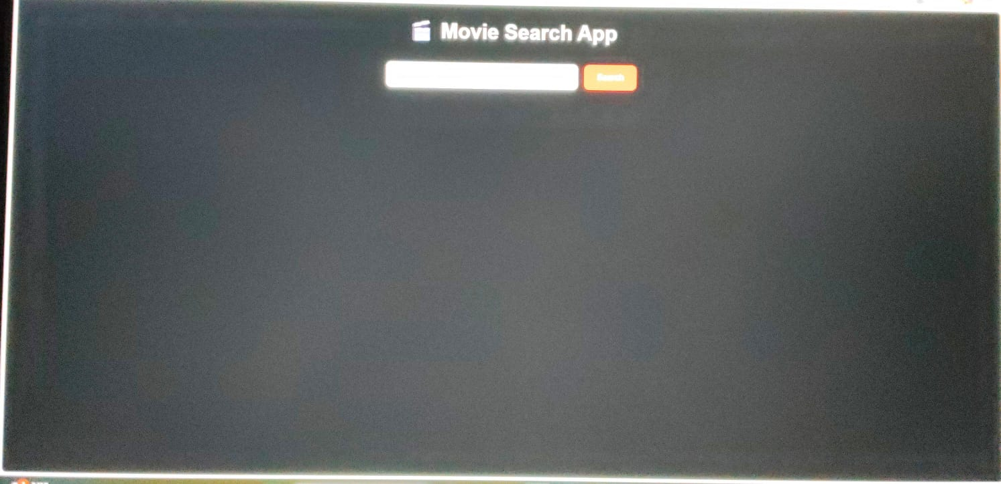

2: Movie Search Interface

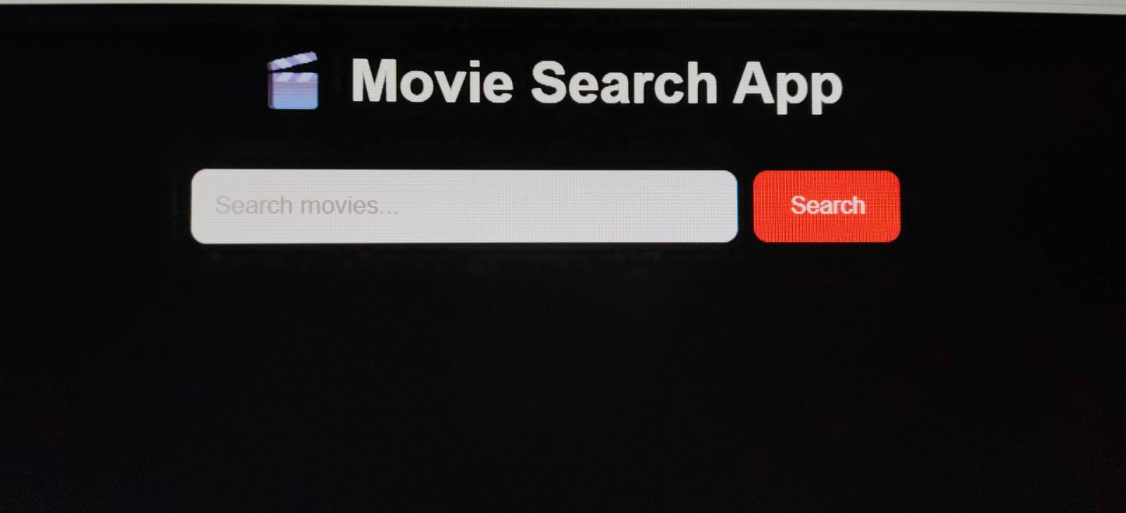
3: Loading State
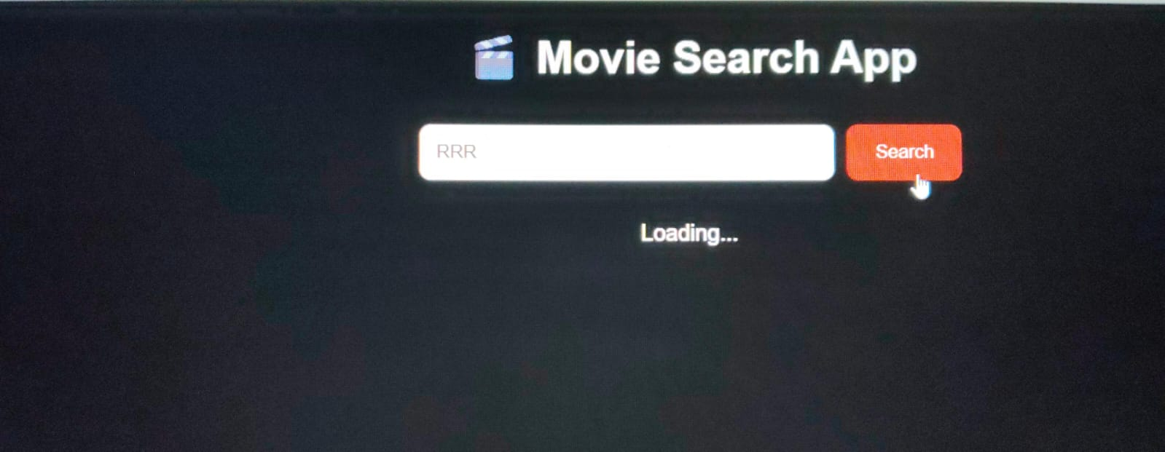

4: Movie Search Results
